**Comprehensive Guide to Overmold Manufacturing**

# Introduction

Overmolding is a manufacturing process in which two different materials are bonded together with the help of an injection molding process that provides excellent adhesion between them. This process uses insert molding or a two-shot process in order to combine stiff plastic base components usually with the outer layer of malleable thermoplastic elastomers. Being an elastomer material, it bears the property to absorb the shock, dampen the vibration, and seals the vacant parts. The over-molding method is widely utilized in sectors like consumer goods, automotive, and electrical components, and medical and health-related industries. Out of numerous examples of over-molding, one such use for comfort and grip is described in further sections.

# Understanding Over-mold Manufacturing

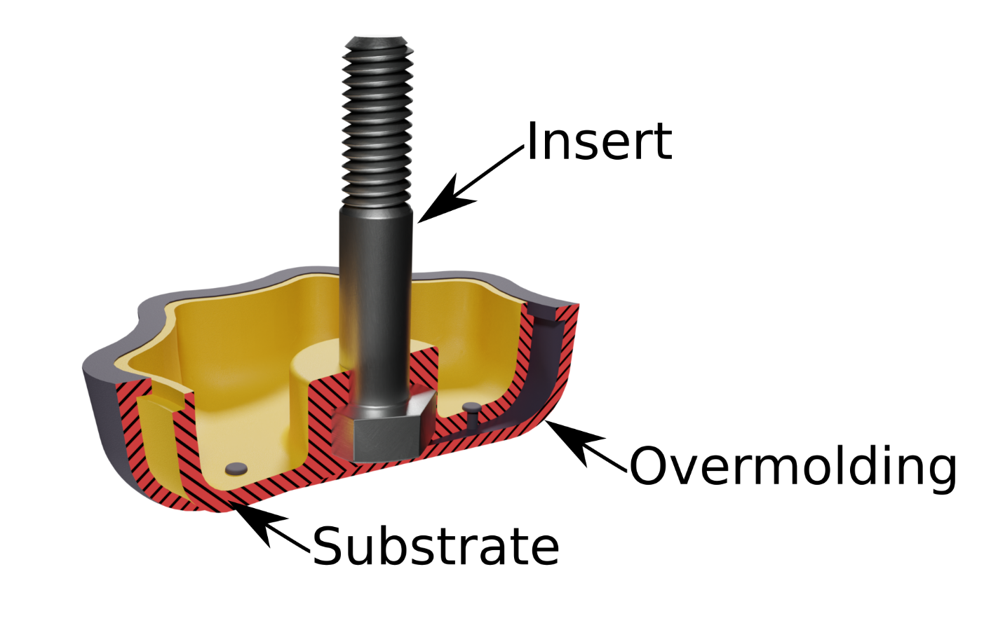

Figure 1 Example of over-mold manufacturing

(Source: <https://jayconsystems.com/blog/the-advantages-and-disadvantages-of-overmolding>)

In the traditional injection molding manufacturing process, for generating a solid product, the molten materials are sent to the mold cavity whereas in the over-molding injection molding process, the material is added to an already-existing object or structure known as the substrate made of metal, plastic or glass. The technique utilizes a variety of materials for the over-mold and you can also include the over-mold with additional components, such as coloring agents and foaming agents, to get the desired outcome for the completed product. There are mainly two types of over-molding processes called insert molding and two-shot over-molding.

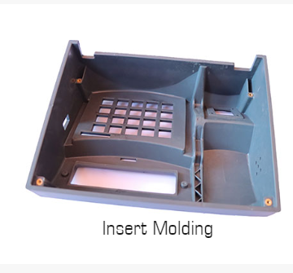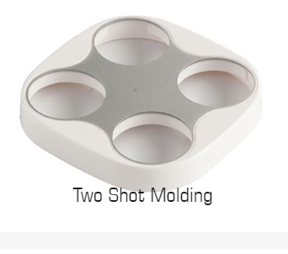

Figure Source: <https://www.key-plast.com/factors-affecting-the-plastic-injection-molding-process.html>

## Insert Molding

Insert molding is used to combine metal and plastics (non-plastic parts are called inserts), or multiple combinations of materials and components into a single unit. The inserted component is mostly a thread or rod and in some rare and complex cases, they can be a battery or motor. The process results in improved wear resistance, tensile strength, study, long-lasting, and weight reduction which is why numerous sectors are utilizing insert molding techniques.

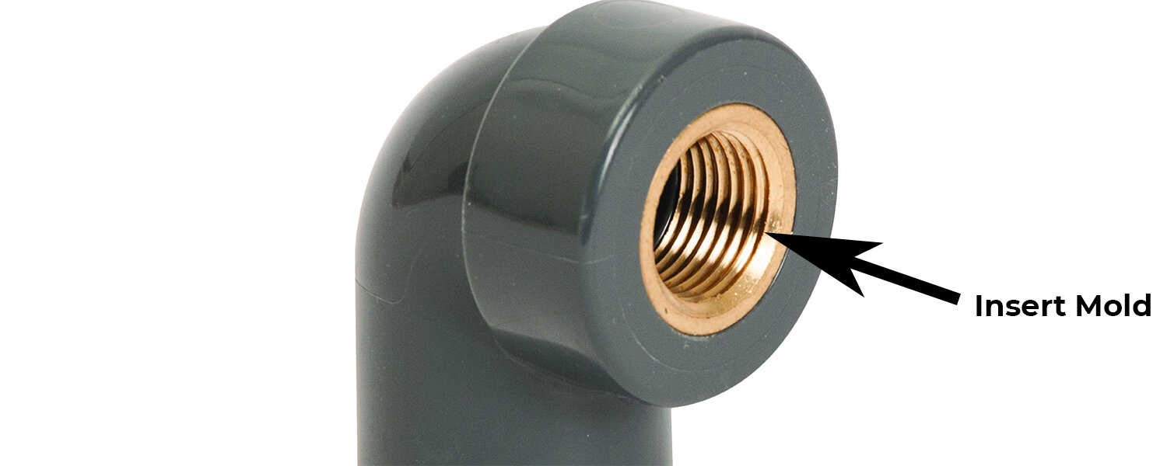

Figure 3 part made from insert molding process

(Source: <https://jayconsystems.com/blog/how-does-insert-molding-work>)

## Two-shot Over-molding

In the two-shot plastic molding process, two separate plastic resins are molded together in a single machining cycle. The two-shot molding technique is divided into two steps where the first involves an injection of resin into a mold, which is then cooled to create a solid object, much like conventional injection molding. The newly-molded object is exported to a second mold in the second stage using a rotating platen or a robotic arm. Depending on the design, the newly-formed part is then given a second injection of resin in or around certain areas of the first mold. Following the formation of a molecular link between the two plastic resins, the multi-resin molded object is cooled and expelled.

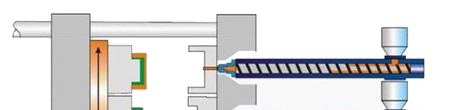

Figure 4Two-shot injection molding

(Source:<https://jayconsystems.com/blog/how-does-insert-molding-work>)

# Materials used in overmold manufacturing

ABS, Acetal, HDPE, LCP, PEI, PMMA, Polycarbonate, Polypropylene, PPA, PPS, PS, PSU, TPE, TPU, PEEK, Liquid Silicone Rubber, etc. are some materials used in over-molding. Some are described below:

1. High-Density Polyethylene (HDPE): HDPE is a widely used polymer in the market as it is advantageous for large components like corrosion-resistant pipework, plastic lumber, and many other components that require special physical performance.
2. Acrylonitrile Butadiene Styrene (ABS): ABS is a material preferred for over-molding operations in applications like electronics or automobile parts. ABS provides several advantages like low melting point, highly recyclable, easily moldable, low heat and electricity conductivity, etc.at a very cheap cost.
3. Polymethyl Methacrylate Acrylic (PMMA): PMMA is a cost-effective polymer preferred in applications like optical, light, and weather ability properties due to its benefits like resistance to UV radiation, high refractive index, chemical resistance, etc.
4. Thermoplastic Elastomer (TPE):  It has shorter mold cycles that help in the two-shot injection molding process by making it easier and less expensive. Although TPE can lose elastic properties at higher temperatures, it is the most suitable plastic for impact resistance.
5. Thermoplastic Polyurethane (TPU):  TPU is highly popular as it has the ability to handle high temperatures and also it is chemical, oil, and abrasion resistant.

# Factors influencing material selection in the over-molding process:

1. Tensile Strength: Tensile strength is the resistance to being pulled apart which determines the material's ability to withstand forces without breaking or losing the elasticity.
2. Izod Impact (Notched) or Toughness: This helps in measuring the impact resistance of the materials by determining the energy required to break a notched sample.
3. Flexural Modulus: It measures the material's flexibility and behavior under bending and loading-unloading conditions.
4. Dielectric Strength: Important for electrical applications, this property helps in determining how resistive in nature the material is.
5. Chemical Resistance: It is required for a material to resist damage when it is exposed to specific chemicals.
6. FDA (Food and Drug Administration) Compliance: It is important for medical or consumer products that require approval for human contact.
7. Thermal Properties: The way the material reacts to heat, maximum and minimum working temperatures, melting temperature, and cooling is critical when using thermoplastic materials. Injection Molding Pressure and Flow Rate: The injection molding process parameters, such as pressure and flow rate severely affect the material's shrinkage and dimensional stability.
8. Cost: Obviously, cost becomes the final determining factor if multiple materials meet the required properties.

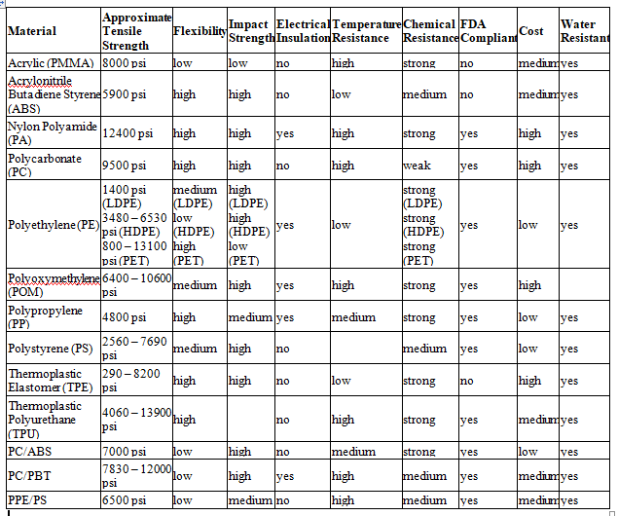

Table 1 **Plastic Material Comparison Chart**

**Source :** [**https://ims-tex.com/injection-molding-materials-selection-guide/**](https://ims-tex.com/injection-molding-materials-selection-guide/)

1. **Design Consideration for over-mold Manufacturing**

The design process needs to begin with a proper understanding and answering questions about the core function of the part, its expected environmental exposure, and the reason for over-molding. This will assist in material selection and overall design optimization.

1. Material Compatibility and Adhesion: Choose materials that have resistance to UV light, chemicals, and other environmental factors. You need to assess the bonding properties of both parts so that the over-molded plastic adheres to the substrate.
2. Support substrate during second shot: You have to maintain adequate support areas on the substrate so that it withstands the pressure exerted during the over-molding process.
3. Wall Thickness: There needs to be consistent wall thickness throughout the part which even plastic flow and also avoid defects like shrink marks and voids.
4. Gate Location: Visible marks on cosmetic parts can be minimized and plastic flow can be optimized with properly planned gate locations.
5. Sealing Features: There should be an effective seal between the substrate and over-mold, mainly when the substrate is plastic.
6. Undercut and Overhangs: To avoid the molding issues and simplify the process, you need to avoid complex undercuts and overhangs in the design as much as possible.
7. Gate and Runner Design: Optimizing gate and runner design makes sure of the proper material flow and distribution during the over-molding process.
8. Production Volume: Factors like expected production volume helps you in selecting the appropriate manufacturing method.
9. Aesthetics and Ergonomics: Over-molding allows for the incorporation of various colors, textures, and ergonomic features, you can use these features to boost the product's visual appeal as well as user experience.
10. **Role of software in over-mold design**
11. CAD (Computer-Aided Design): CAD software is used to create detailed 3D models of the over-molded part for visualization. It makes the process easy in necessary modifications and ensures that the over-molded component aligns perfectly with the substrate. It also allows for precise and accurate measurements, helping in the development of perfect prototypes and final molds.
12. Mold Flow Analysis: Mold flow simulation software is employed to predict the flow of molten material and helps engineers to optimize the design, identify potential issues, and avoid defects like air traps, voids, or insufficient material flow. By examining different cases, engineers can make data-driven decisions to improve the design and increase manufacturing efficiency.
13. Material Selection: Overmolding often involves using different materials with particular properties for the substrate and the over-mold. Software tools can help in selecting appropriate materials by analyzing factors like material compatibility, adhesion characteristics, mechanical properties, and chemical resistance.
14. Tools Design and Simulation: Overmolding requires specialized molds to shape the substrate and overmold material together. The software aids in designing these molds, considering factors such as part geometry, material behavior, and molding machine capabilities. Simulation tools help predict potential issues during the molding process and optimize the mold design before actual production.
15. Prototyping and Testing: This part allows us to make the work easy through 3D printing and CNC machining so that engineers could validate the over-mold design, test its functionality, and assess its performance without involving the high costs associated with full-scale production.
16. **Advantages and challenges of over-molding manufacturing**

The numerous advantages of the over-molding process in manufacturing industries are given below.

1. Custom plastic parts

For any business-related work, the over-molding process allows for designing and producing unique plastic components. Over-molded items with bigger dimensional quality can be produced by manufacturers using a plastic-plastic or metal-plastic combination. Almost any type of consumer or industrial object may be produced using the over-molding process, including grips, handles, kitchen items, knobs, electronic components, and automobile parts.

1. Improve product performance

Despite the advantageous qualities of popular resins used in injection molding such as water proofness, chemical resistance, and durability, the inclusion of additional material dramatically surges the performance of the finished product. Because over-molded items have the two-material advantage that companies employ for many purposes, they are of superior quality. For example, there are many hardware tools with grips composed of plastic and rubber.

1. Enhanced shock absorption

Over-molding also offers a variety of goods along with outstanding shock absorption. Compared to non-over-molded items, the product can have a longer shelf life and better resistance to physical impacts with this characteristic. This is an important quality to take into consideration, particularly in industrial, structural, or automotive applications where the material's endurance is of the most importance. Some of the high shock absorption polymers are Rubber, silicone, or neoprene.

Common challenges and solutions in over-mold manufacturing:

|  |  |
| --- | --- |
| Challenges | Solutions |
| Poor adhesion | * Re-select the correct grade of TPE * Check for color concentrate compatibility * Increase the mold temperature |
| Incomplete filling of the substrate or overmold | * Increase the shot size and injection pressure * Increase injection speed and melting temperature |
| Flashing of the overmold | * Increase tonnage or decrease injection and pack pressure * Check for substrate sinks and re-cut the tool |

1. **Case Studies**
   1. **Car trims**

Metal or plastic pieces that are located in the door edge, side body, bumper, fender, wheel and other locations in the interior of automobiles are called car trims. Car trims are used explicitly in lowering the weight of the vehicle. As over-molding is a flexible plastic manufacturing technology, the customer's desired colors can be integrated intoS pre-set automotive trims.

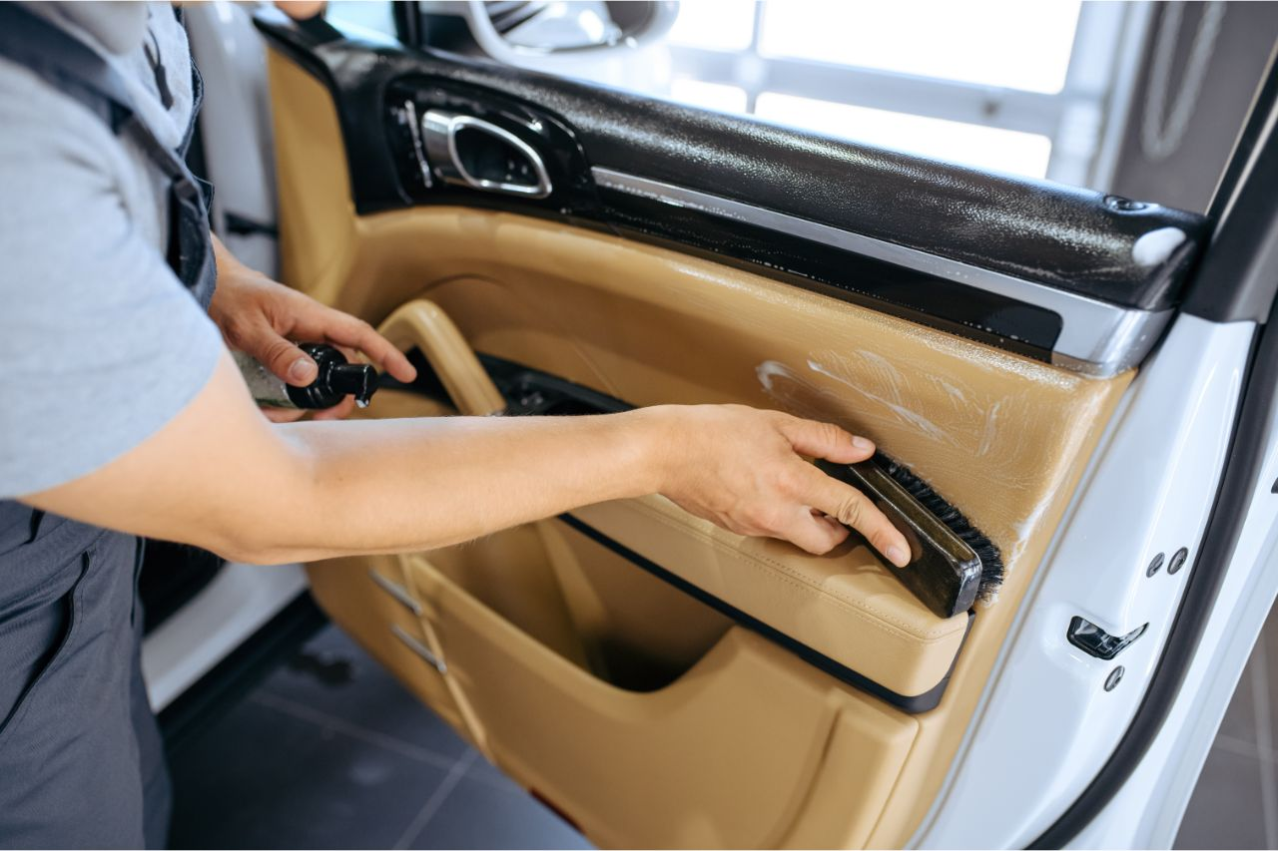

Figure 5Car trims

(Source:https://richfieldsplastics.com/blog/applications-overmolding)

* 1. **Surgical Devices**

As we know, the most important factors in the medical sector are precision and product safety; professionals like physicians, surgeons, and nurses should be able to rely on safe plastic material. Over-molding is used to make a variety of medical goods, including housing for equipment and surgical instruments, to produce syringes, patient monitors, needles, dilators, soft-touch buttons, etc.



Figure 6Surgical devices manufacturing from over-molding

(Source:https://richfieldsplastics.com/blog/applications-overmolding)

1. **Innovative solution for the over-molding process**
2. **3d printing for prototyping**

An over-molded component prototype is quick, cheap, and affordable because of the technology of 3D printing. Engineers may use it to make sophisticated and complex geometries and test the over-mold idea with just the 3D printed prototype.

1. **In-mold sensors**

New technology for directly embedding sensors into over-molded components has made it possible for predicting maintenance needs and tracking product performance. In automotive or aerospace applications, over-molding strain sensors can identify possible failures and breakdowns that facilitate proactive maintenance and increases safety.

1. **Over-molding with forms and electronic components**

Foam over-molding's main purpose is to lower the total weight of a product while improving its performance. Direct electrical component integration into over-molded parts can result in more durable and compact products.

1. **Future of overmolding process**

The future of overmold manufacturing holds exciting advancements and innovations. Advanced materials, such as high-performance thermoplastics and bio-based polymers, will enhance product performance. The performance of the product will be improved by using advanced materials including bio-based polymers and high-performance thermoplastics. IoT and AI-based industry 4.0 technologies will enable smart manufacturing, process optimization, and quality control. Overmold tooling will increasingly be produced using additive manufacturing, which offers design freedom and shorter lead times. Electronic circuits will be integrated into over-molded items directly using in-mold electronics, resulting in products that are small and light. Eco-friendly and productive production will be fueled by robotics and automation. To improve patient comfort and safety, over-molding will become more prevalent in medical equipment. Micro and Nano over-molding applications for the electronics and medical sectors will grow as a result of miniaturization developments. Overall, these trends will revolutionize various industries with enhanced performance, reduced costs, and environmental consciousness.

1. **Conclusion**

Due to the capacity of over-molding to satisfy exacting requirements and complete difficult jobs, it is widely used in a variety of industries like consumer products, automotive, and electrical components, with a focus on the medical and healthcare sectors. Overmolding has several benefits, including the ability to modify plastic components, enhance product performance, provide shock absorption, and lower production costs. With material selection, mold design, and process optimization, issues including poor adhesion, partial filling, and flashing may be resolved. The future of over-mold manufacturing will be fueled by creative solutions like 3D printing for prototypes, in-mold sensors, over-molding with foams and electronics components, and developments in material science. Moreover, automation and Industry 4.0 technologies will boost output and quality, and the incorporation of electronic circuits into over-molded components will provide products that provide better performance, cost-effectiveness, and sustainable solutions.